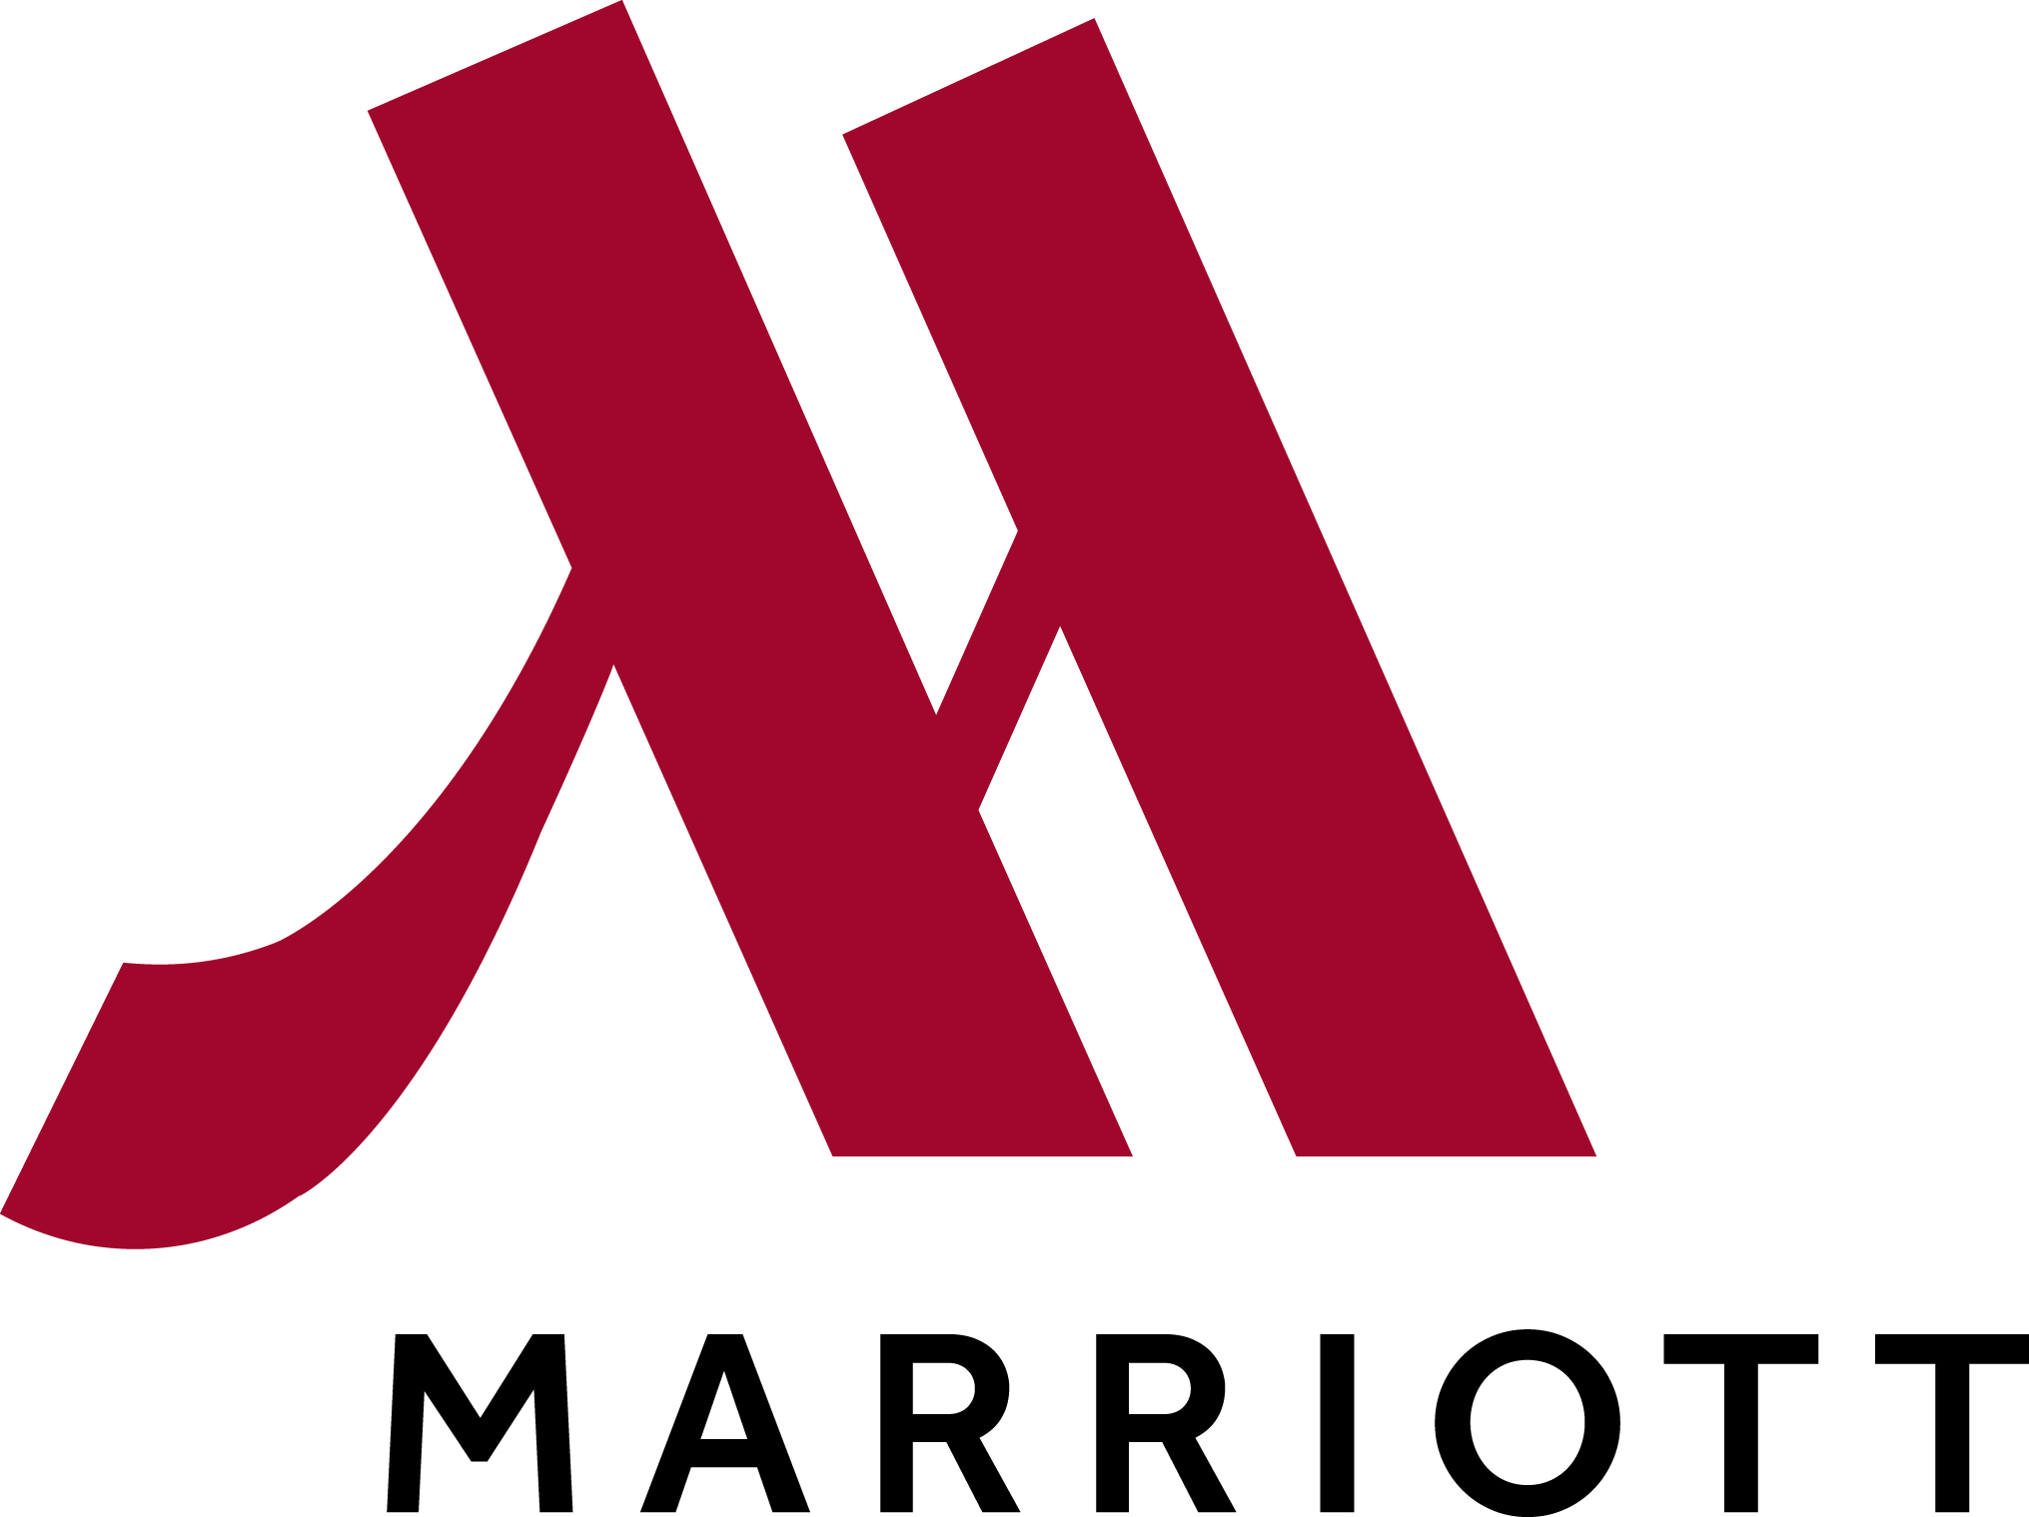

Overland Park Marriott
10800 Metcalf Avenue
Overland Park, KS 66210-2320
(913) 451-8000

Use the link provided to book your reservations. Make sure you complete before the cutoff date.

USSSA Midwest State Championship Girls/D3 Boys Ref# M-2OM0DWS
Date | Day | Standard Double | Total Rooms
02/20/2015 | Fri | 15 | 15
02/21/2015 | Sat | 15 | 15

Start Date | End Date | Room Type | Rate
02/20/2015 | 02/22/2015 | Standard Double | $94.00
Cutoff date: Friday, February 6, 2015
Book your group rate for ussa midwest state championship girls d3 boys

March Basketball Mania Kickoff Ref# M-2OMEG8E
Date | Day | Standard Double | Total Rooms
03/06/2015 | Fri | 10 | 10
03/07/2015 | Sat | 10 | 10

Start Date | End Date | Room Type | Rate
03/06/2015 | 03/08/2015 | Standard Double | $94.00
Cutoff date: Friday, February 20, 2015

Book your group rate for MARCH BASKETBALL MANIA

Madness in March Shoutout
Date | Day | Standard Double | Total Rooms
03/13/15 | Fri | 10 | 10
03/14/15 | Sat | 10 | 10

Book your group rate for Madness in March Shootout

USSSA National Qualifier Ref# M-2OM5ZZC
Date | Day | Standard Double | Total Rooms
04/24/2015 | Fri | 15 | 15
04/25/2015 | Sat | 15 | 15

Start Date | End Date | Room Type | Rate
04/24/2015 | 04/26/2015 | Standard Double | $104.00
Cutoff date: Friday, April 3, 2015

Book your group rate for USSSA National Qualifier

MO/KAN State Championships Ref# M-2OMA6ZW
Date | Day | Standard Double | Total Rooms
05/01/2015 | Fri | 15 | 15
05/02/2015 | Sat | 15 | 15

Start Date | End Date | Room Type | Rate
05/01/2015 | 05/03/2015 | Standard Double | $109.00
Cutoff date: Friday, April 10, 2015

Rock the Rim National Qualifier Ref# M-2OMGD65
Date | Day | Standard Double | Total Rooms
05/15/2015 | Fri | 15 | 15
05/16/2015 | Sat | 15 | 15

Start Date | End Date | Room Type | Rate
05/15/2015 | 05/17/2015 | Standard Double | $104.00
Cutoff date: Friday, April 24, 2015

Book your group rate for Rock the Rim National Qualifier May2015

Midwest Summer Regional Championships Ref# M-2OMGDM9
Date | Day | Standard Double | Total Rooms
06/26/2015 | Fri | 15 | 15
06/27/2015 | Sat | 15 | 15

Start Date | End Date | Room Type | Rate
06/26/2015 | 06/28/2015 | Standard Double | $104.00
Cutoff date: Friday, June 5, 2015

Book your group rate for Midwest Summer Regional Championships

