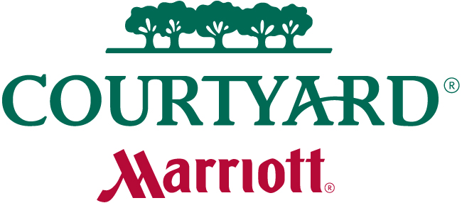

Courtyard Overland Park Convention Center
11001 Woodson Avenue
Overland Park, KS 66211
(913) 317-8500

Use the link provided to book your reservations. Make sure you complete before the cutoff date.

USSSA Midwest State Championship D1/D2 Boys Ref# M-2PH02XR
Date | Day | King w/Sofa  Sleeper | Total Rooms
02/27/2015 | Fri | 15 | 15
02/28/2015 | Sat | 15 | 15

Start Date | End Date | Room Type | Rate
02/27/2015 | 03/01/2015 | King w/Sofa Sleeper | $79.00
Cutoff date: Friday, February 13, 2015

Book your group rate for USSSA Midwest State Championship D1/D2 Boys

March Mania Crossover Classic Ref# M-2OMJIBT
Date | Day | King w/Sofa  Sleeper | Total Rooms
03/20/2015 | Fri | 10 | 10
03/21/2015 | Sat | 10 | 10

Start Date | End Date | Room Type | Rate
03/20/2015 | 03/22/2015 | King w/Sofa Sleeper | $94.00
Cutoff date: Friday, February 27, 2015

Book your group rate for March Mania Crossover Classic

USSSA National Qualifier Ref# M-2PH031V
Date | Day | King w/Sofa  Sleeper | Total Rooms
04/24/2015 | Fri | 15 | 15
04/25/2015 | Sat | 15 | 15

Start Date | End Date | Room Type | Rate
04/24/2015 | 04/26/2015 | King w/Sofa Sleeper | $79.00
Cutoff date: Friday, April 3, 2015

Book your group rate for USSSA National Qualifier

MO/KAN State Championships Ref# M-2PH034P

Date | Day | King w/Sofa Sleeper | Queen | Total Rooms
05/01/2015 | Fri | 5 | 10 | 15
05/02/2015 | Sat | 5 | 10 | 15

Start Date | End Date | Room Type | Rate
05/01/2015 | 05/03/2015 | King w/Sofa Sleeper | $79.00
05/01/2015 | 05/03/2015 | Queen Queen | $99.00

Cutoff date: Friday, April 10, 2015

Book your group rate for MO/KAN State Championships_KING

Rock the Rim National Qualifier Ref# M-2OMGD65

Date | Day | King w/Sofa Sleeper | Queen Queen | Total Rooms
05/15/2015 | Fri | 5 | 10 | 15
05/16/2015 | Sat | 5 | 10 | 15

Start Date | End Date | Room Type | Rate
05/15/2015 | 05/17/2015 | King w/Sofa Sleeper | $89.00
05/15/2015 | 05/17/2015 | Queen Queen | $109.00

Cutoff date: Friday, April 24, 2015

Book your group rate for Rock the Rim National Qualifier_KING

Midwest Summer Regional Championships Ref# M-2OMGDM9

Date | Day | King w/Sofa Sleeper | Queen Queen | Total Rooms
06/26/2015 | Fri | 10 | 5 | 15
06/27/2015 | Sat | 10 | 5 | 15

Start Date | End Date | Room Type | Rate
06/26/2015 | 06/28/2015 | King w/Sofa Sleeper | $94.00
06/26/2015 | 06/28/2015 | Queen Queen | $114.00

Cutoff date: Friday, June 5, 2015

Book your group rate for Midwest Summer Regional Championships_KING

